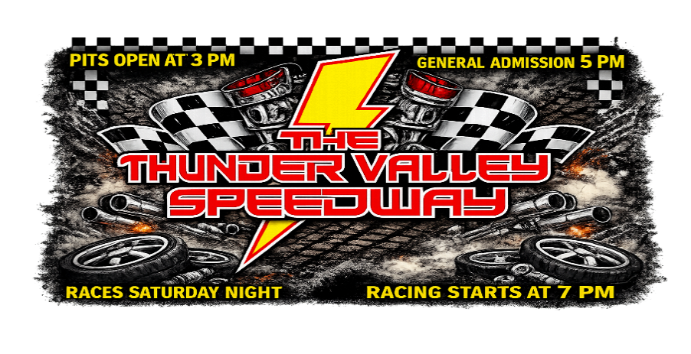

2026 General Rules

- All drivers, owners, or pit crew must maintain control of their children in the pit area, grandstands, or parking lot of The Thunder Valley Speedway. Unattended and/or unruly children can result in your disqualification and suspension from The Thunder Valley Speedway.
- No one under the age of 16 years old is permitted to operate ATVs, UTVs, golf carts, etc. on The Thunder Valley Speedway property.
- Fire suits REQUIRED in all divisions. Note: It is also recommended that all drivers wear fire retardant shoes, gloves, and underwear.
- Helmets are required in all divisions and must be worn at all times car is on the track. Helmet must have face and eye protection. (This means shield or goggles.) Neck braces are also required. Head restraints REQUIRED for Late Model and Crate Late Model.
- Racing type seats are required and must be securely fastened. NO FIBERGLASS SEATS
- Shoulder harness is mandatory. A quick release harness no less than 3” wide is mandatory. This harness must be mounted in at least 5 points below the driver’s shoulders. Both ends must be fastened to roll cage with quality bolts no less than 3/8” in diameter. Belts shall come from behind driver.
- Fire extinguishers are mandatory in pit area. Recommended Minimum of 2 lbs. fire extinguisher securely mounted within reach of the driver.
- Kill switch is required within easy reach of the driver.
- Tow hooks, front and rear, are required.
- Electric fuel pumps are prohibited. There will be some exceptions where mechanical fuel pump cannot be used.
- Car numbers and letters must be at least 20 inches high and neatly painted on both sides of the car, on the door only. A number and letters 20 inches high are required to be painted on the roof reading from the passenger’s side. Numbers and letters must sharply contrast with the car’s paint scheme so that the numbers are easily read.
- All cars must retain a clean, neat, professional appearance. The management reserves the right to refuse entry to any vehicle that displays offensive language, offensive signage, or anything else deemed offensive.
- No nitrous oxide allowed. Gasoline shall not be blended with alcohols, ethers, or other oxygenates and shall not be blended with an aniline or its derivatives, nitro compounds or other nitrogen compounds.
- All cars must start under their own power. No direct drives allowed. All cars must have a working reverse gear.
- Any car endangering race conditions on the track (dragging loose parts, leaking fluids, smoking, or deliberate rough driving, etc.) will be black flagged for that race.
- All cars and any part of a car are subject to inspection by track officials at any time.
- No equipment shall be considered as having been approved by reason of having passed through inspection unobserved.
- Drive shaft loops are mandatory for all classes. Suggested 2” X 1/4” thickness minimum. Drive shafts must be painted white or florescent orange.
- Any attached weights must be securely bolted to frame and must be painted white or florescent orange and have car number clearly painted on them. Due to the high­risk factor involved, any car that loses a lead weight during any event will be disqualified for that race and may be banned from the track for the season and/or fined. Two attaching mounts are recommended. No weights may be attached to rear bumper. No lead pellets – no liquid weights.
- All glass, mirrors, chrome, and flammable material must be removed from all cars.
- All sheet metal must be securely fastened. Hoods must be kept in place at all times.
- All cars must have working brakes.
- All cars must have a firewall with no holes between the motor, the fuel tank, and the driver’s compartment.
- Rollbar padding is recommended for all classes.
- Window nets are recommended for all classes.
- Safety regulations will be enforced at all times.
- All drivers must have their name, address, and social security number on file prior to being paid.
- Driver may change cars at any time between qualifying/heats/B Main and the start of the Main
Event. However, any change will result in the driver starting on the rear of his heat/B Main or Main
Event. It is the driver’s responsibility to notify the track officials of any desired change before the race.
The driver & car will be disqualified if track officials are not notified prior to the next race.
- With the purchase of a pit pass, each competitor or spectator agrees to all the terms and conditions set forth in the rules.
- Anything determined to be detrimental to the sport will be grounds for immediate removal, suspension, or being banned from the track.
- Tires may not be wrapped in any way once they are bolted on the car upon entrance to the racetrack property.
- NO SPEEDING IN THE PITS – SPEED LIMIT IS 5 MPH. This includes 4­wheelers and all types of pit vehicles. If you are found to be speeding through the pits with your race car or any other type of vehicle you will be asked to leave immediately and are subject to suspension from The Thunder Valley Speedway. There will be no justification for speeding through the pits in any situation. There are too many people, and the likelihood of a tragedy makes this inexcusable.
- Competing in multiple classes: If a driver is scheduled to run in back­to­back races, he or she should notify an official as soon as the line­ups are posted. The car for the next race needs to be staged in the tech shed area. This will ensure that the driver is given adequate time to switch cars and join the line­up of the next race minutes after the last race.
- The Thunder Valley Speedway reserves the right to inspect, tech, and disqualify any car during the evening’s racing event or while the car is on The Thunder Valley Speedway’s premises.
- By entering an event at The Thunder Valley Speedway, competitors agree to The Thunder Valley Speedway testing tires on the car, in their pit area, and their trailer at any time. Refusal to allow for testing will result in the immediate dismissal from the night’s activities and the car and driver will be escorted out of the pits. Refusal to submit to tire tests is subject to a long­term suspension from The Thunder Valley Speedway as well.
- Tires suspected of being altered chemically can be confiscated by The Thunder Valley Speedway for testing.
- Drivers that have tires deemed illegal by testing will be subject to penalties per the sanctioning body
&/or the following track penalties:
    - 1st Offence – 2­week suspension and $250 fine.
    - 2nd Offence – 90­day suspension and $500 fine.
    - 3rd Offence – To be determined by track officials.
- Tire changing procedures during a race.
  - Jack & Tire must be in the hot pit area. Signs are posted for these areas at track entrance & track exit for those parked on the backside.
  - Track official will let the crew members know when it is safe to enter the area for tire change. c. You cannot go to the trailer.
  - 2 pit crew members only.
  - Pit crew members cannot work on any other part of the car. If there is a fender that needs to be pulled or anything else hanging from the car or rubbing the tires, find a track official to assist in fixing this problem.
  - Pit crews are given 3 laps to complete a tire change.
  - The driver goes to the rear for changing a flat.

PROTEST RULE
- Any driver in the same race on the lead lap may protest another car immediately after feature in the tech area.
- $250 cash per component. $50.00 to the track & $100 for testing.
- If legal, the protested car gets $100.00.
- If found illegal, the protestor gets $100.00 back.

Tech
Top Three cars go to tech after Heat Race’s and Feature Race’s
ONLY Driver and One Member From Each Team Allowed in Tech Shed

